Gold Market Risk Analysis in R
Returns, Tail Risk, Simulation, and GARCH Volatility
Zakariya Boutayeb | September 2026

1. Project overview

This project studies the market risk of gold using R. It retrieves daily gold futures prices, calculates returns at several horizons, examines the return distribution, estimates Value at Risk (VaR) and Expected Shortfall (ES), and models changing volatility with a GARCH(1,1) model.
- Asset: COMEX gold futures, Yahoo Finance symbol GC=F.
- Requested sample: 31 December 2006 to 31 December 2023.
- Observed sample: 4,275 daily log returns after cleaning and the required removal of the computed first return.
- Software: R with quantmod, xts, MASS, and rugarch.

2. Returns and calendar aggregation

A discrete return measures the percentage change in price.
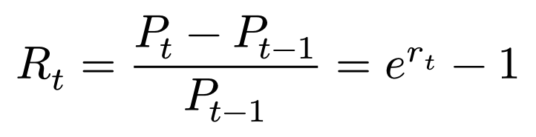
A log return measures the logarithmic price change and is additive across time.
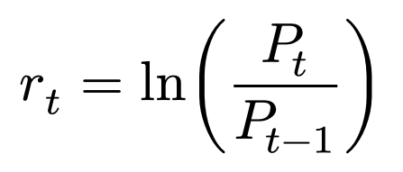

For monthly, quarterly, and yearly periods, daily log returns are summed. A period discrete return is then obtained by exponentiating the summed log return and subtracting one.

Measure | Date | Return
First daily log return | 2007-01-03 | -0.012834
First monthly discrete return | 2007-01-31 | 0.026448
Last quarterly log return | 2023-12-29 | 0.109712
Last yearly discrete return | 2023-12-29 | 0.133374

3. One-day VaR and Expected Shortfall

VaR is the loss threshold associated with a chosen lower-tail probability.
At 99% confidence, alpha = 0.01. ES is the average return conditional on being below the VaR threshold, so it describes the severity of the worst 1% of outcomes.
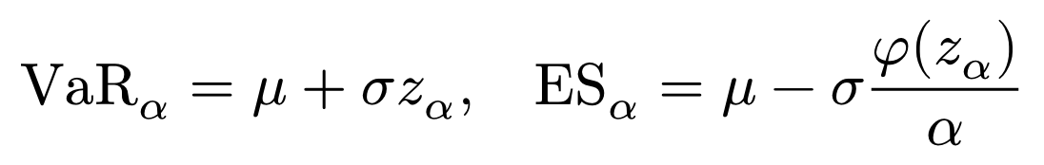
Estimate | Return
Mean daily log return | 0.000275
Daily standard deviation | 0.011126
Normal 99% VaR | -0.025607
Normal 99% ES | -0.029377
Simulated-normal 99% VaR | -0.025903
Simulated-normal 99% ES | -0.029754
Empirical-bootstrap 99% VaR | -0.030927
Empirical-bootstrap 99% ES | -0.042093

The empirical ES is substantially more negative than the normal ES. This shows that the normal model understates the observed downside tail. For a $1 billion position, the most conservative of these one-day ES estimates is approximately -$42,093,480.

4. Distribution diagnostics and Student-t risk

Skewness measures asymmetry and kurtosis measures tail weight. Gold returns are slightly negatively skewed and strongly leptokurtic. The Jarque–Bera statistic is therefore very large, rejecting a normal return distribution.

Diagnostic or parameter | Estimate
Skewness | -0.244569
Kurtosis | 8.708181
Jarque–Bera statistic | 5846.523263
Student-t location (m) | 0.000451
Student-t scale (s) | 0.008747
Student-t degrees of freedom | 7.457972

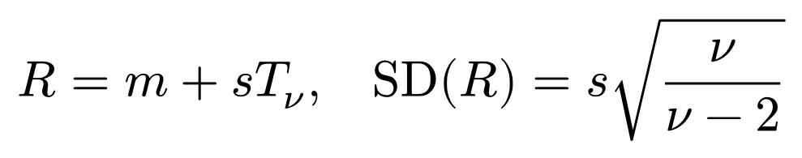
Risk estimate | ES
Fitted Student-t, one day, 99% | -0.031570
Fitted Student-t simulation, 10 days | -0.084946
Empirical IID simulation, 10 days | -0.101676
Consecutive-block simulation, 10 days | -0.122120

The block method produces the most negative 10-day ES because it preserves runs of consecutive returns and therefore retains short-run dependence and volatility clustering. The IID methods break that ordering.

5. Time-series diagnostics

The autocorrelation function (ACF) tests whether current observations are related to earlier observations.
Raw gold returns show no strong persistent serial correlation, but absolute returns show clear positive persistence.
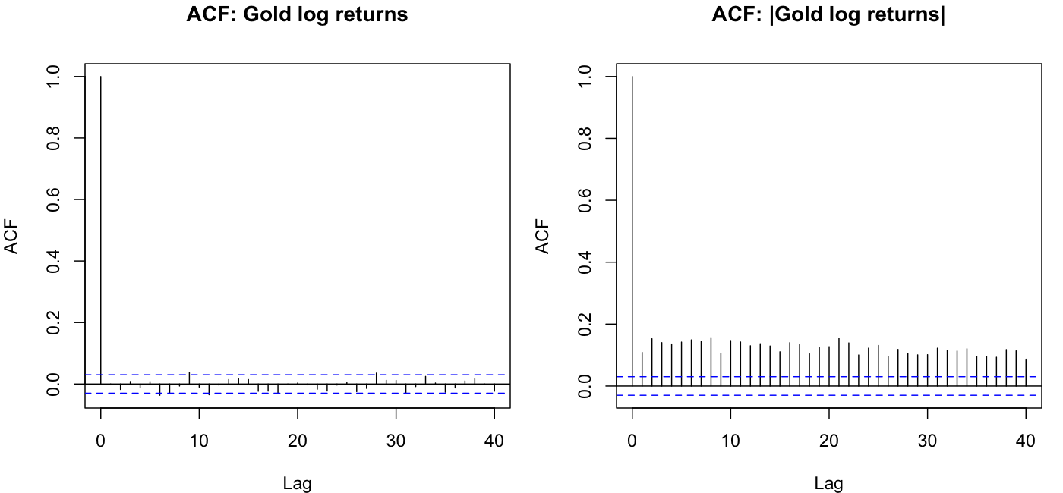
Figure 1. ACF of gold returns and absolute gold returns.

Most return autocorrelations are close to zero, so past return direction provides little evidence of predictability. The persistent autocorrelation in absolute returns indicates volatility clustering: Large price movements tend to be followed by large movements, and small movements by small movements.

6. GARCH(1,1)-t model

The GARCH model allows conditional variance to change over time. Its variance equation combines a long-run component, the previous squared shock, and the previous conditional variance.
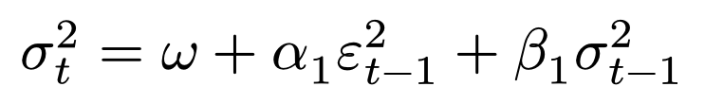
Model result | Estimate
alpha1: response to new shocks | 0.033700
beta1: volatility persistence | 0.962349
Student-t shape parameter | 4.403162
Persistence, alpha1 + beta1 | 0.996048
Bootstrap one-day 95% VaR | -0.014475
Bootstrap one-day 95% ES | -0.021511

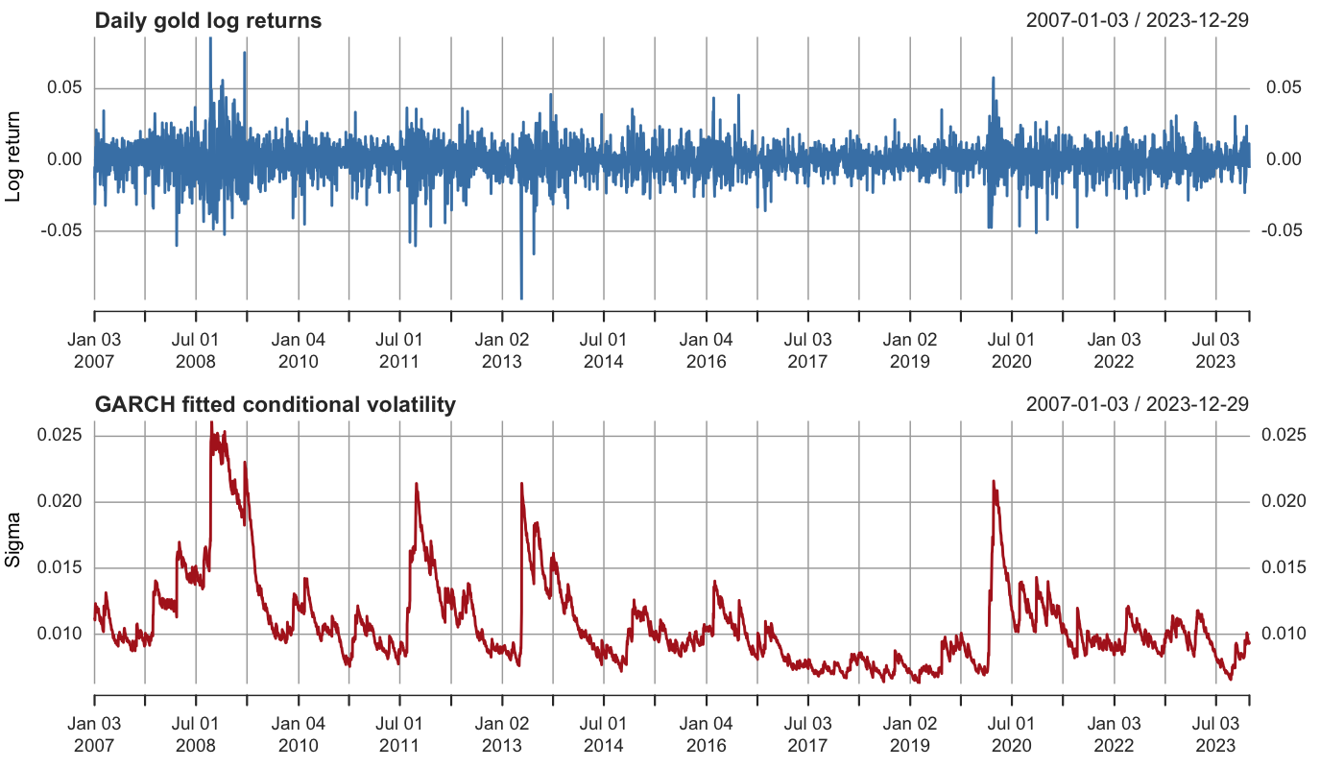
Figure 2. Daily gold returns and fitted GARCH conditional volatility.

Estimated volatility rises sharply during turbulent periods and declines gradually afterward. Persistence is close to one, meaning that volatility shocks decay slowly and risk remains elevated after major market moves.

7. Main conclusions

- Gold returns are not normally distributed; they have heavy tails and mild negative skewness.
- Normal VaR and ES underestimate downside risk relative to empirical and heavy-tailed approaches.
- Absolute-return autocorrelation confirms volatility clustering.
- The GARCH(1,1)-t model captures time-varying volatility and produces risk estimates that respond to current market conditions.
- For a multi-day horizon, block simulation is the most conservative method in this sample because it preserves consecutive return patterns.

8. Limitations

GC=F is a futures-price proxy rather than a spot gold series. Results depend on the selected sample, model specification, confidence level, and simulation method. A production risk system should also use out-of-sample forecasting, VaR backtesting, alternative asymmetric volatility models, and transaction or liquidity considerations.

